St. Teresa’s Catholic Primary School



Annual SEND Report
July 2025

Head Teacher: Mr V Turner
SENCo: Miss R McTernan

St Teresa’s is an average sized primary school situated in Heaton, Newcastle, catering for pupils aged 4-11. Pupil premium funding is below national average (22.5%) and those who do not have English as their first language is high (32%)

At St Teresa’s we are committed to ensuring that all pupils, including those with special educational needs and disabilities (SEND), receive their right to a high quality and accessible curriculum. Children’s all-round development is paramount to us and we endeavour to provide children with a wide range of experiences and opportunities so that they experience success and are well equipped for the future.

Our aim is to provide all children with the best possible outcomes in preparation for life- long learning. We believe it is important that children acquire skills, knowledge and confidence that can be applied to all future learning experiences, including social, physical and spiritual development. We endeavour to raise aspirations and expectations for all pupils, including those pupils with SEND by working in partnership with parents/carer and listening to pupils.
Children with Special Educational Needs and Disabilities at St Teresa’s School are supported to reach the highest standard they possibly can. This is made possible through careful and thoughtful provision for children with Special Educational Needs. Regular monitoring and pupil progress meetings support the assessment and next steps for pupils with Special Educational Needs and Disabilities. All SEN pupils have targets set on their individual SEN Support Plans. These are reviewed termly in a formal meeting with the school SENCO or at a parent’s evening. The outcome of bespoke and recommended interventions are recorded on the SEND Support plans.
Demographics

Number of pupils with SEN 2024- 2025
Total number of pupils on roll | 209
Total number of SEN pupils in school | 29
Number of pupils at SEN Support | 23
Number of pupils at EHCP Level | 6
% of SEN pupils (inc EHCP) | 13.8%
No. of learners who are SEND and PP | 14
No. of learners who are SEND and EAL | 8
No. of learners who are SEND, PP and EAL | 5

Percentage of SEND population (per age phase)

Age Phase | No. of chn with SEND | Total number in age phase | % of pupils with SEND in age phase
EYFS | 1 | 29 | 3.5%
Key Stage 1 | 5 | 60 | 8.3%
Lower Key Stage 2 | 10 | 61 | 16.4%
Upper Key Stage 2 | 13 | 59 | 22%

Primary Areas of Need (29 children in total)

Communication and Interaction: 13
Cognition and Learning: 11
Social, emotional and mental health: 2
Sensory and Physical: 3

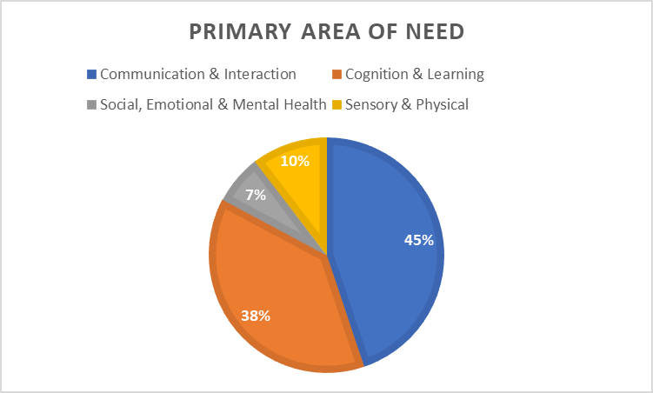

Attendance 2024-25 of pupils with SEND
SEND Persistent Absence: 13.8% of SEND pupils (4/29)

Exclusions
Three pupils on the SEND register have been given temporary exclusions in this academic year.
Two pupils were each given a one-day exclusion due to their behaviour. Both of these pupils have an EHCP and both exclusions were given in the autumn term; none since.
One pupil has had five separate temporary exclusions over the course of the year, ranging from one day to five days. This child has an EHCP. The last temporary exclusion was given in the spring term.

Next Steps
Ensure that attendance for pupils with SEND remains high and continue to support parents in getting their children to school every day through the school’s attendance initiatives. Continue to encourage the use of breakfast club.

Data/Outcomes for pupils with SEND

 | No. of SEND pupils (K SEND Support) |  | % of SEND Pupils achieved standard
 |  |  | School
EYFS | 1 | Good Level of Development | 0%
 |  |  | School
Year 1 Phonics | 2 | Phonics Screening | 50%
 |  |  | School
KS1 SATS (Y2) | 3 | EXS or GDS  Reading  Writing  Maths  Combined | 33.3%  33.3%  33.3%  33.3%
 |  |  | School
KS2 SATs (Y6) | 7 | EXS or GDS:  Reading  Writing  Maths  Combined | 57.1%  42.8%  42.8%  28.5%

NEXT STEPS
Continue to monitor the provision of SEND pupils and the SENCO to continue to monitor pupils support plans termly to ensure that advice and recommendations are being used and that targets being set are challenging yet achievable.

SEND TOP-UP FUNDING

Child | Funding Type | Funding total
Child A | EHCP Band D | £5790
Child B | EHCP Band B | £1160
Child C | EHCP Band C | £2890
Child D | EHCP Band C | £2890
Child E | EHCP Band E | £8090
Child F | EHCP Band C | £2890
Child G | IPS Funding | £1000

STAFF TRAINING
Subject - Emotionally Based School Avoidance
Sensory Processing
All staff- Trauma workshop led by Educational Psychologist

Safeguarding Refresher- all staff – Clennell Services
DSL Refresher: SMT
First Aid at Work- Teaching assistants
CPOMs Training
Quality First Teaching/ Assess, Plan, Do, Review- for teachers led by SENCo
Development of Effective SEND Support Plans- for teachers led by SENCo
Thrive- Emma Kemp is now a trained Thrive practioner
LA SENCo networks
SENCo- Peer to peer group meetings
SEND Trust networks

NEXT STEPS
Regular SEND training sessions will be incorporated into the staff schedule during the academic year. The SENCO to ensure that individual staff have appropriate CPD when needed. The impact of the SEND Mainstream Guidance Document will be monitored through classroom drop ins and discussions with staff.

Working with Outside Agencies
Educational Psychology (Jill Sandeman BBCET)
Newcastle University S&L
S&L Therapy Department (NHS)
SENDOS
CYPS/ CAMHs (NHS)
Occupational Therapy (NHS)
Physiotherapists (NHS)
School Health (NHS)
Next Steps Counselling service
Newcastle LA SEMH Team
Newcastle LA LIP Panel
BBCET Specialist Literacy Teacher (Rachel Cleife BBCET)

NEXT STEPS
To continue to work closely with all services to support pupils and improve quality first teaching through training and recommendations.
Monitor the effectiveness of the services we buy in and the impact on our pupils, ensuring that we are getting value for money.
To promote outdoor learning and forest school for our pupils with SEN.

PUPIL VIEWS
Pupils are consulted throughout the target setting process and are aware of their individual targets.
Pupils are encouraged to have a voice in school and they know who the adults are that they can pass on worries or concerns to. Classrooms have ‘A Time to Chat’ boxes for children to privately ask for help when needed. There is an ethos where children feel comfortable and are encouraged to talk to their peers and staff.

NEXT STEPS
To attend pupil participation events within Newcastle e.g. music and sport
To encourage the attendance of pupils at their review meetings, in particular Annual reviews so that can be involved in discussions.
To continue to encourage SEND pupils to take-up after school clubs.

PARENT/CARER VIEWS
St Teresa’s has positive attitudes to parents/carers and values their important role in their child’s education. Parents/carers are always informed when their child is placed on the SEN register and the graduated response, outlined in the Code of Practice, is explained to them. Parents are informed about the Newcastle Special Educational Needs and Disabilities Information Advice and Support Service. This service provides, advice and support at any stage of a child or young person’s education, and provides an Independent Supporter for families in the process of getting an Education Health and Care Plan. Parents are fully informed in the review process. Written information is in accessible formats and sufficient notice is given for meetings to enable parents/carers time to prepare. We collect the views of parents/carers in a variety of ways.

NEXT STEPS
Repeat the parent questionnaires to obtain more parent voice.
Provide a SEND information workshop for parents.

NEWCASTLE LOCAL OFFER
Please follow the link below to access the Newcastle Local Offer for further information on services linked to SEN and Disability in Newcastle.

Newcastle SEND Local Offer | Newcastle Support Directory

